Муниципальное бюджетное общеобразовательное учреждение
«Средняя общеобразовательная школа № 17 имени И.Л.Козыря
пос. Шаумянского»

Методическая разработка
внеклассного мероприятия «75 years ago…»,
посвященного 75-ой годовщине победы
в Великой Отечественной войне
(для обучающихся 7 классов)

Автор: Цыганкова Тамара Александровна,
учитель английского языка

2020 г.
Введение
В настоящее время одной из ключевых задач образования является воспитание у обучающихся чувства патриотизма. Связь между современным поколением и теми, кто пережил страшное военное время, становится все тоньше. Поэтому учителя, независимо от предмета, который они преподают, должны в рамках своих уроков воспитывать у учащихся гордость и уважение к подвигу старшего поколения, готовность защищать свою Родину в любой момент. Представленная методическая разработка внеклассного мероприятия направлена на изучение и повторение исторического материала о подвиге нашего народа в страшной войне.
Цель мероприятия:
Обучающие: вспомнить вместе сучащимися о героях и событиях II мировой войны, активизировать употребление лексических единиц по теме.
Развивающие: развивать и совершенствовать навыки чтения, устной речи, умения быстро отвечать на поставленные вопросы.
Воспитательные: воспитывать чувство патриотизма и гордости за подвиг нашего народа.
Метапредметные связи: история, литература
Оборудование: компьютер, карточки с текстом, карточки с заданиями
Аудитория: обучающиеся 7 класса
ХОД МЕРОПРИЯТИЯ
- Организационный момент.
Т: Hello, boys and girls! Glad to see you! Today we have a very interesting lesson. We shall have a competition. Two teams will take part in our competition. You can see our guests….
The topic of our lesson is ««75 years ago…».
Teacher (учитель читает отрывок стихотворения «Священная война»):
Get up, the giant country
Get up, for mortal fight
With the dark fascist force
With the damned horde

Let noble fury
Boil up in a wave
There is a people’s war
There is a holy war

Like two opposed poles
We are enemies about everything
We fight for light and peace
Whereas they fight for darkness.
You are divided into two teams and now I ask our captains to introduce yourself and the members of your teams.
- The first round is warming up (команды отвечают на вопросы, жюри считает кто быстрее и правильнее отвечает):
- When is Victory Day?
- When did the Great Patriotic War start?
- Who was the leader of Nazi Germany?
- What happens in all cities and towns on the 9th of May?
- Name of the Russian soldier whose monument stands in Bulgaria?
- Which city was blockaded for 900 days during the War?
- What are the colours of George ribbon?
- The best tank of the Soviet army during the World War II?
- What is one of the symbols of the victory in the World War II?
- Конкурс «The famous Russians»
Teacher: Let’s speak about the famous people of those days.
Who is on the picture?
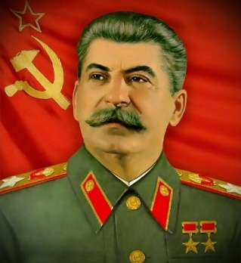
- G. Zhukov
- I. Stalin
- M. Kutuzov
- P. Bagration

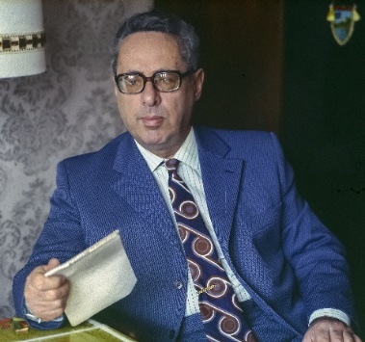
Whose voice sounded on the all-Union radio, announcing the beginning of the Second World War?
- V. Sinyavsky
- O. Vysotskaya
- I. Kirillov
- Y. Levitan

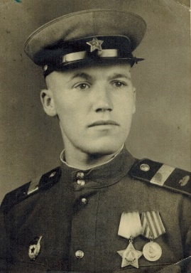
What is the name of the intelligence officer, Paul Siebert, who eliminated 11 German generals?
- Dmitri Medvedev
- Kirill Orlovsky
- Vladimir Molodtsov
- Nikolai Kuznetsov
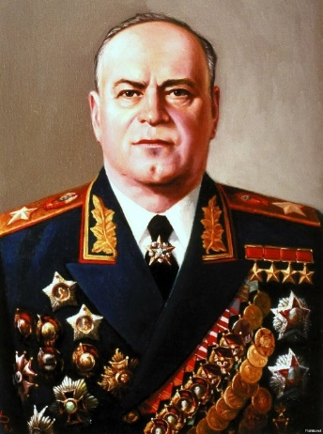
Who is on the picture?

- G. Zhukov
- L. Govorov
- A. Vasilevsky
- F. Tolbukhin

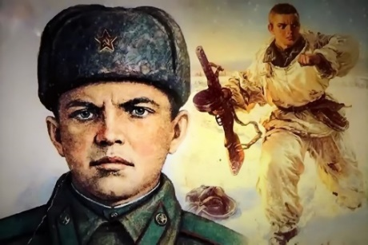
He is a hero of the war. He closed enemy’s weapon with his body. Look at his photo. Who is on the picture?
- A. Matrosov
- L. Golikov
- N. Gastello
- E. Osipenko

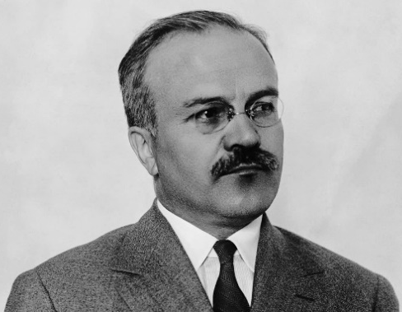
Name a Soviet politician who spoke on the radio on June 22, 1941 with the words: "Our cause is right, the enemy will be defeated, victory will be ours»!
- G. Malenkov
- V. Molotov
- N. Voronov
- K. Voroshilov

3. Конкурс на знание военной техники

Teacher: Let’s remember the famous military equipment of the Great Patriotic War

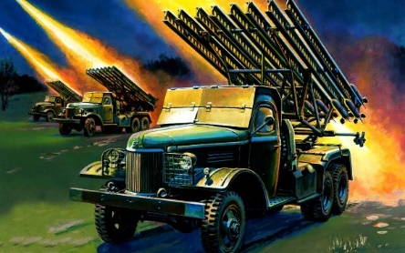
- What was the name of this weapon?
- Katyusha
- Victoria
- Vera
- Nadezhda

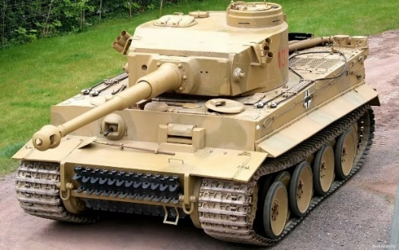
German heavy tank of World War II.
- Tiger
- Mouth
- Lion
- Partner
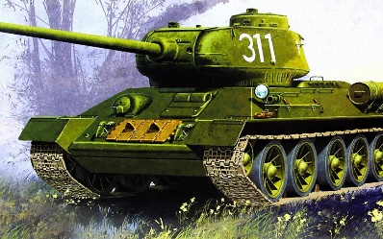
The best tank of the Soviet army during the World War II?
- T-34
- T-50
- T-28
- M4 Sherman

4. Конкурс «The magic numbers» (командам необходимо как можно быстрее подобрать правильные ответы)

How many days did the Great Patriotic War last?
In what year did the World War II begin?
How many days was Leningrad blockaded during the World War II?

How many hero cities we have in 2020?

How many tanks took part in the battle of Kursk?

When was the Soviet flag sat over the Reichstag building?

How many days did the battle of Stalingrad last?

1418, 1941, 900, 12, 6000, 1200, 1.05.1945, 200.

5. Конкурс «Russian wartime song» (задание по аудированию, прослушивают песню и заполняют пропуски)
Тeacher : Now, I want you listen to Russian wartime song, written during World War II. You should fill into the gaps while listening to the song.
Katyusha
Music: M. Blanter Lyrics: M Isakovsky
_______ trees and pear trees were a ________,
River mist was rising all around.
Young Katyusha went strolling by the _______
On the steep banks,
O'er the rocky ground.
By the river's bank she sang a ___________
Of her hero in a distant land.
Of the one she'd dearly loved for so long,
Holding tight his _______ in her hand.
Oh, my song, _______ of a maiden's true love,
To my dear one travel with the ______.
To the one who Katyusha loves so,
Bring my ________ to him, one by one.
Let him know that I am true and faithful,
Let him hear the love song that I send.
Tell him as he defends our _________ that grateful,
True Katyusha our love will defend.

Now, let’s sing that song together. (Поют песню)

Тeacher: Pupils, our lesson comes to the end. I think you loved it. What can you say about today’s lesson? Did you liked it? What information was the most interesting.
(ученики высказывают мнение по мероприятию, жюри подводит итоги)

Teacher: More than seventy years have passed since the victory in the Great Patriotic war, but it still finds reflection in human souls. This victory was achieved with great effort. Every family in the country was touched and involved into this cruel war. Victory Day is a symbol of a national pride, glory. It consolidates and joins everybody today. In our country Victory day is celebrated by all people in every city, town, village, because it brought peace not only for the Soviet People but for the people of many European countries. I’m glad that you know the history of Russia! We must remember the Great Patriotic War and its heroes, honour the memory of those who gave their lives for the freedom.
Our competition is over. Thank you very much! Good Bye!

